**Day 3 - Algorithms - Searching: Linear and Binary Search**

**Problem 1:** Implement a Binary Search and Linear search Algorithm

**Problem 2:** Given a sorted array and a number key, find the index of the first and last occurrence of the key in the array. If the key is not present, return [-1, -1].

**Examples 1**

Array: [1, 2, 3, 3, 3, 4, 4, 5]

Number: 3

Answer: [2, 4]

**Examples 2**

Array: [1, 2, 3, 3, 3, 4, 4, 5]

Number: 5

Answer: [7, 7]

**Problem 3:** Given a sorted array containing distinct integers and a number 'key', find the index of the key in the array. If the key is not present, return the index at which it would be inserted considering that we need to maintain the sort order.

**Examples 1**

Array: [1, 2, 3, 4, 5]

Number: 3

Answer: 2

**Examples 2**

Array: [1, 2, 3, 5]

Number: 4

Answer: 3

**Problem 4:** You are an IT company's manager. Based on their performance over the last N working days, you must rate your employee. You are given an array of N integers called workload, where workload[i] represents the number of hours an employee worked on an ith day. The employee must be evaluated using the following criteria: Rating = the maximum number of consecutive working days when the employee has worked more than 6 hours.

You are given an integer N where N represents the number of working days. You are given an integer array workload where workload[i] represents the number of hours an employee worked on an ith  day.

Task: Determine the employee rating.

Example

Assumptions

* N = 12
* workload = [2, 3, 7, 8, 7, 6, 3, 8, 12, 11, 12, 10]

Approach

Workload with consecutive hours > 6 = [2, 3, 7, 8, 7, 6, 3, 8, 12, 11, 12, 10] =>  Longest Interval =  [8,12,11,12,10]. Therefore return 5.

**Input format**

* The first line contains an integer N denoting the number of working days.
* The second line contains a space-separated integer array workload where workload[i] represents the number of hours an employee worked on an ith day.

**Output format**

Print the employee rating.

**Constraints**

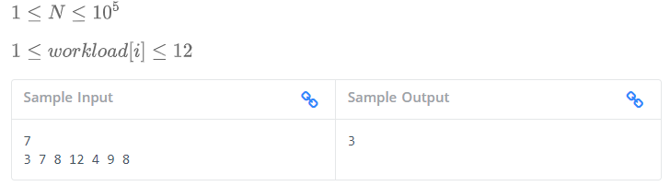

—--------------------------- END —---------------------------